Winner for Christmas Challenge 2023

1.Winner CRT SS7900 Special Edition 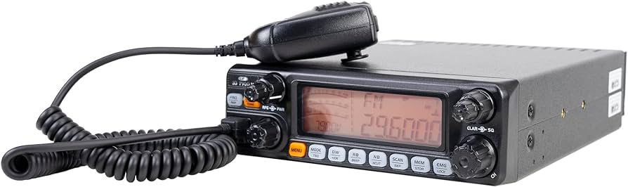
Goes to 72EK101 Brent !!!

2.Winner CRT SS 6900 Special Edition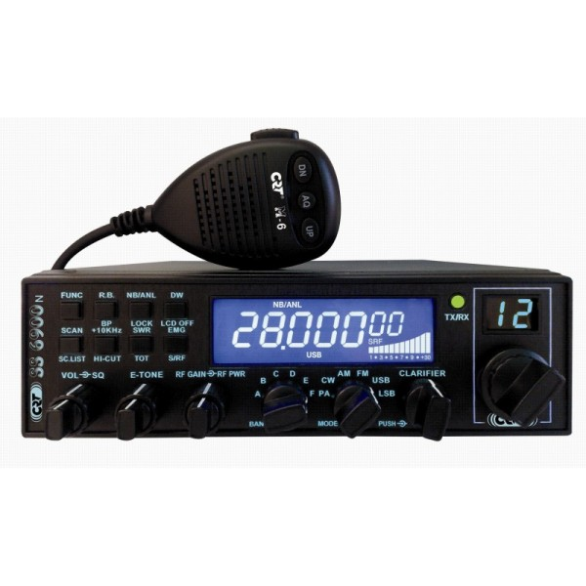
Goes to 91EK211 Ridwan

3.Winner 3 Ele. Yagi S 27 MHZ (27Y3S)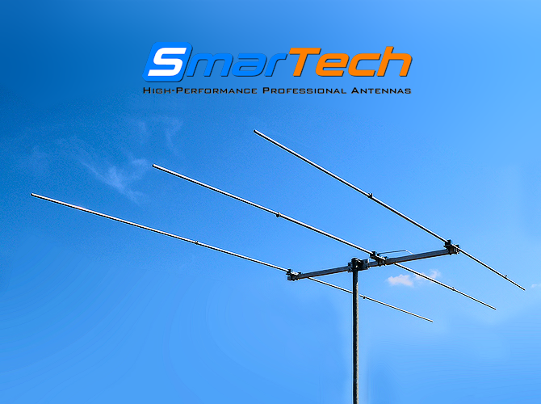

Goes to 20EK020 Frank

4. 5. And 6. Winner 3D printed QRZ Sign 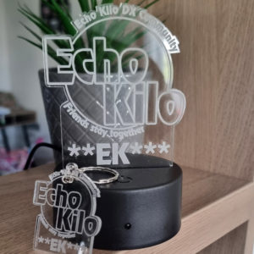
Goes to 13EK019 Andy, 18EK102 Eugene 2EK925 Ron
7. 8. 9. 10. Winner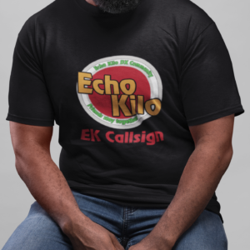
EK T-Shirt with EK Logo and Callsign
19EK567 Bert, 13EK420 Robin, 26EK023 Damain, 19EK121 Bas
11. and 12. Winner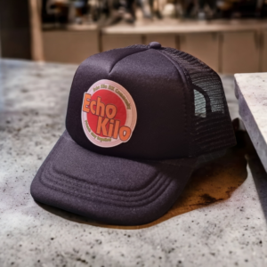
30EK069 Javier, 93EK101 Brian

13. Special Voucher Gift about 30€ fort he EK Shop (Sponsored by Andrew 2EK010)
91EK422 Coky

14. and 15.Winner Acrylic keychain Antenna with Echo Kilo logo and QRZ from EK Shop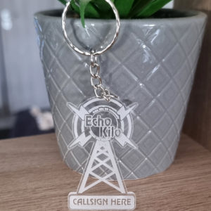 2EK286 Gary, 14EK087 Didier
16. 17. Winner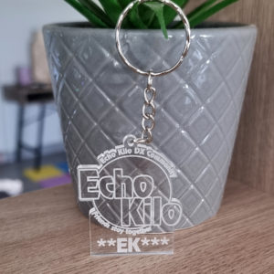
14EK137 Henri, 1EK300 Orazio

18. 18.20. Winner Get a Voucher Gift for Alex Radio Shop Germany
13EK991 Timo, 13EK333 Wolfgang, 13EK013 Jürgen

